Name: Đinh Hoàng Sáng

ID: BEBEIU17022

**HOMEWORK**

**BIOSIGNAL PROCESSING**

*Problem 1:*

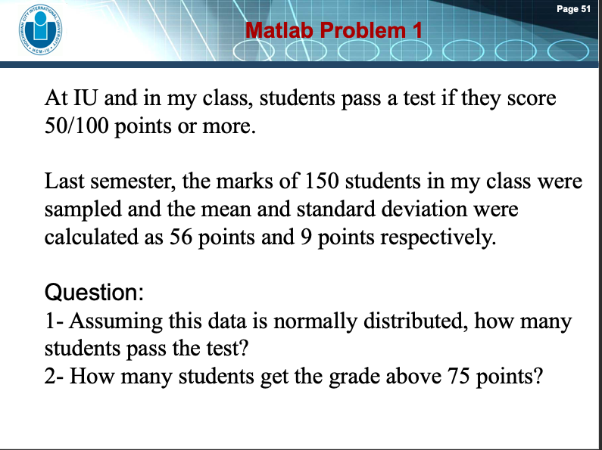Assuming this data is normally distributed,

With mean=56, standard deviation=9

A/

x=1:1:100;

y=normpdf(x,56,9);

a=150*sum(y(50:100))

There are ***115 students*** that pass the test since their grade is between 50 and 100

B/

b=150*sum(y(76:100))

***There are 2 students*** get the grade above 75 points

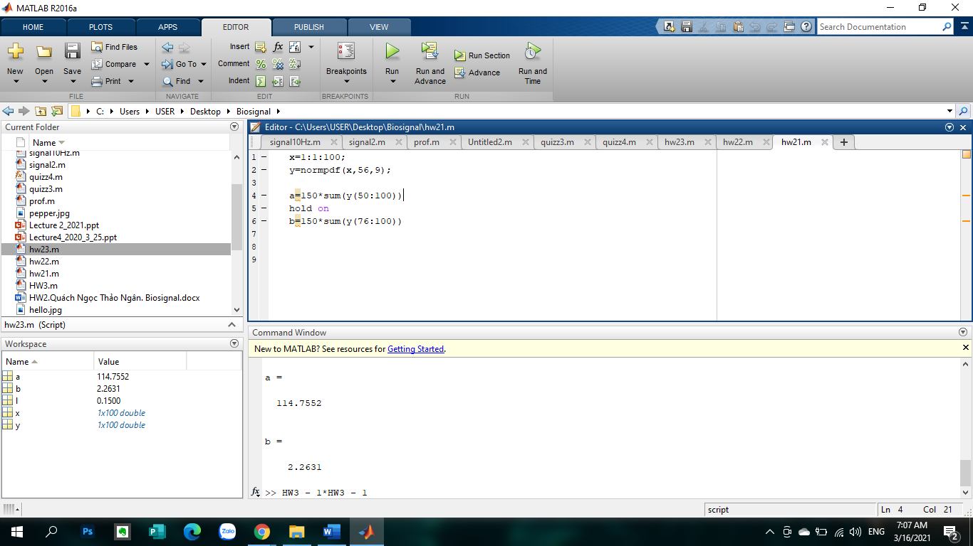

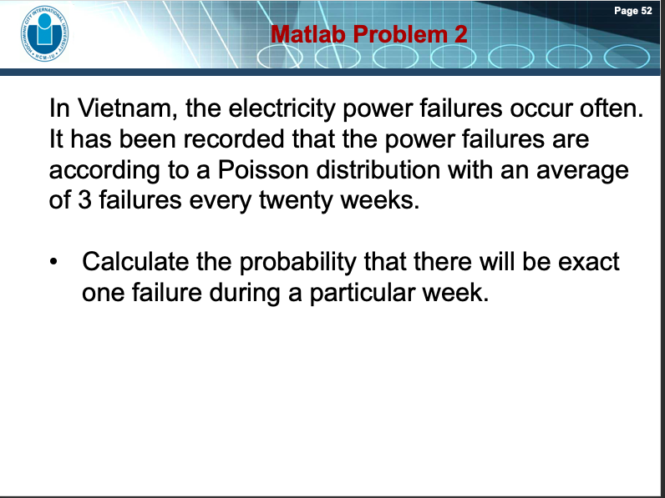

*Problem 2:*

l=3/20;

x=0:1:10;

y=poisspdf(x,l);

a=sum(y(2:2))

The probability that there will be exact one failure during a particular week is ***12.91%***

+Mean is 3/20 because of 3 failures per 20 weeks

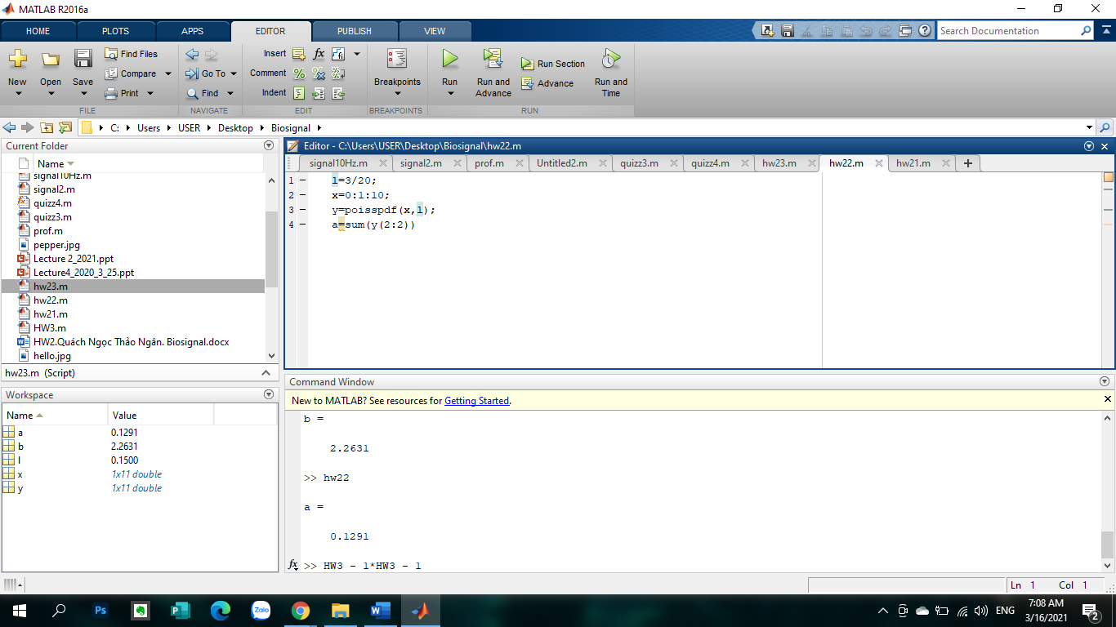

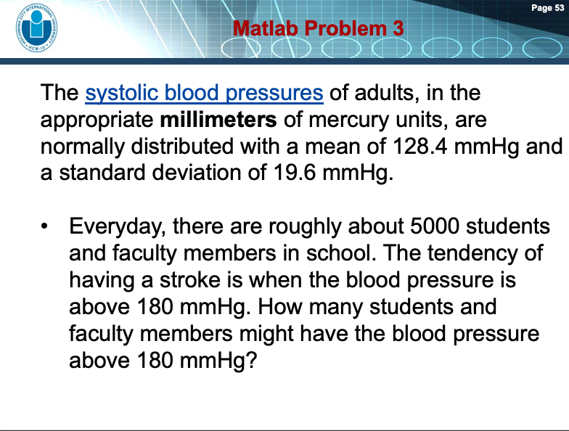*Problem 3:*

Assuming the systolic blood pressures of adults in a range of 0 to 220mmHg:

x=0:1:270

y=normpdf(x,128.4,19.6)

plot(x,y)

5000*sum(y(181:271))

There are ~ *23 people might have the blood pressure above 180 mmHg*

